Chocolate Consumption, Cognitive Function, and Nobel Laureates

* Franz H. Messerli, M.D.

ietary flavonoids, abundant in plant-based foods, have been shown to improve cognitive function. Specifically, a reduction in the risk of dementia, enhanced performance on some cognitive tests, and improved cognitive function in elderly patients with mild impairment have been associated with a regular intake of flavonoids.[1,2](https://www.nejm.org/doi/full/10.1056/NEJMon1211064) A subclass of flavonoids called flavanols, which are widely present in cocoa, green tea, red wine, and some fruits, seems to be effective in slowing down or even reversing the reductions in cognitive performance that occur with aging. Dietary flavanols have also been shown to improve endothelial function and to lower blood pressure by causing vasodilation in the peripheral vasculature and in the brain.[3,4](https://www.nejm.org/doi/full/10.1056/NEJMon1211064) Improved cognitive performance with the administration of a cocoa polyphenolic extract has even been reported in aged Wistar–Unilever rats.[5](https://www.nejm.org/doi/full/10.1056/NEJMon1211064)

Since chocolate consumption could hypothetically improve cognitive function not only in individuals but also in whole populations, I wondered whether there would be a correlation between a country's level of chocolate consumption and its population's cognitive function. To my knowledge, no data on overall national cognitive function are publicly available. Conceivably, however, the total number of Nobel laureates per capita could serve as a surrogate end point reflecting the proportion with superior cognitive function and thereby give us some measure of the overall cognitive function of a given country.

## Methods

A list of countries ranked in terms of Nobel laureates per capita was downloaded from Wikipedia (<http://en.wikipedia.org/wiki/List_of_countries_by_Nobel_laureates_per_capita>). Because the population of a country is substantially higher than its number of Nobel laureates, the numbers had to be multiplied by 10 million. Thus, the numbers must be read as the number of Nobel laureates for every 10 million persons in a given country.

All Nobel Prizes that were awarded through October 10, 2011, were included. Data on per capita yearly chocolate consumption in 22 countries was obtained from Chocosuisse ([www.chocosuisse.ch/web/chocosuisse/en/home](http://www.chocosuisse.ch/web/chocosuisse/en/home)), Theobroma-cacao ([www.theobroma-cacao.de/wissen/wirtschaft/international/konsum](http://www.theobroma-cacao.de/wissen/wirtschaft/international/konsum)), and Caobisco ([www.caobisco.com/page.asp?p=213](http://www.caobisco.com/page.asp?p=213)). Data were available from 2011 for 1 country (Switzerland), from 2010 for 15 countries, from 2004 for 5 countries, and from 2002 for 1 country (China).

## Results

**Figure 1.**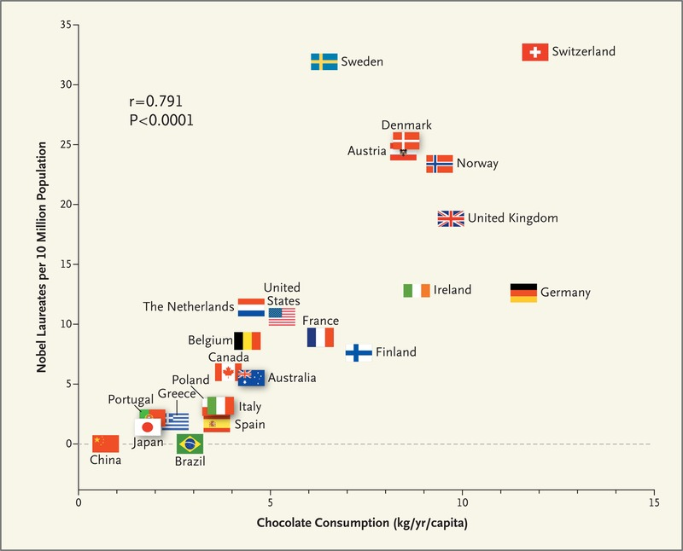Correlation between Countries' Annual Per Capita Chocolate Consumption and the Number of Nobel Laureates per 10 Million Population.

There was a close, significant linear correlation (r=0.791, P<0.0001) between chocolate consumption per capita and the number of Nobel laureates per 10 million persons in a total of 23 countries ([Figure 1](https://www.nejm.org/doi/full/10.1056/NEJMon1211064)). When recalculated with the exclusion of Sweden, the correlation coefficient increased to 0.862. Switzerland was the top performer in terms of both the number of Nobel laureates and chocolate consumption. The slope of the regression line allows us to estimate that it would take about 0.4 kg of chocolate per capita per year to increase the number of Nobel laureates in a given country by 1. For the United States, that would amount to 125 million kg per year. The minimally effective chocolate dose seems to hover around 2 kg per year, and the dose–response curve reveals no apparent ceiling on the number of Nobel laureates at the highest chocolate-dose level of 11 kg per year.

## Discussion

The principal finding of this study is a surprisingly powerful correlation between chocolate intake per capita and the number of Nobel laureates in various countries. Of course, a correlation between X and Y does not prove causation but indicates that either X influences Y, Y influences X, or X and Y are influenced by a common underlying mechanism. However, since chocolate consumption has been documented to improve cognitive function, it seems most likely that in a dose-dependent way, chocolate intake provides the abundant fertile ground needed for the sprouting of Nobel laureates. Obviously, these findings are hypothesis-generating only and will have to be tested in a prospective, randomized trial.

The only possible outlier in [Figure 1](https://www.nejm.org/doi/full/10.1056/NEJMon1211064) seems to be Sweden. Given its per capita chocolate consumption of 6.4 kg per year, we would predict that Sweden should have produced a total of about 14 Nobel laureates, yet we observe 32. Considering that in this instance the observed number exceeds the expected number by a factor of more than 2, one cannot quite escape the notion that either the Nobel Committee in Stockholm has some inherent patriotic bias when assessing the candidates for these awards or, perhaps, that the Swedes are particularly sensitive to chocolate, and even minuscule amounts greatly enhance their cognition.

A second hypothesis, reverse causation — that is, that enhanced cognitive performance could stimulate countrywide chocolate consumption — must also be considered. It is conceivable that persons with superior cognitive function (i.e., the cognoscenti) are more aware of the health benefits of the flavanols in dark chocolate and are therefore prone to increasing their consumption. That receiving the Nobel Prize would in itself increase chocolate intake countrywide seems unlikely, although perhaps celebratory events associated with this unique honor may trigger a widespread but most likely transient increase.

Finally, as to a third hypothesis, it is difficult to identify a plausible common denominator that could possibly drive both chocolate consumption and the number of Nobel laureates over many years. Differences in socioeconomic status from country to country and geographic and climatic factors may play some role, but they fall short of fully explaining the close correlation observed.

## Study Limitations

The present data are based on country averages, and the specific chocolate intake of individual Nobel laureates of the past and present remains unknown. The cumulative dose of chocolate that is needed to sufficiently increase the odds of being asked to travel to Stockholm is uncertain. This research is evolving, since both the number of Nobel laureates and chocolate consumption are time-dependent variables and change from year to year.

## Conclusions

Chocolate consumption enhances cognitive function, which is a sine qua non for winning the Nobel Prize, and it closely correlates with the number of Nobel laureates in each country. It remains to be determined whether the consumption of chocolate is the underlying mechanism for the observed association with improved cognitive function.

References:

1. Nurk E, Refsum H, Drevon CA, et al. Intake of flavonoid-rich wine, tea, and chocolate by elderly men and women is associated with better cognitive test performance. J Nutr 2009;139:120-127
   * [Crossref](https://www.nejm.org/servlet/linkout?suffix=r001&dbid=16&doi=10.1056%2FNEJMon1211064&key=10.3945%2Fjn.108.095182)
   * [Web of Science](https://www.nejm.org/servlet/linkout?suffix=r001&dbid=128&doi=10.1056%2FNEJMon1211064&key=000261777100021)
   * [Medline](https://www.nejm.org/servlet/linkout?suffix=r001&dbid=8&doi=10.1056%2FNEJMon1211064&key=19056649)

[Google Scholar](http://scholar.google.com/scholar?hl=en&q=Nurk%2C+E%2C+Refsum%2C+H%2C+Drevon%2C+CA%2C++Intake+of+flavonoid-rich+wine%2C+tea%2C+and+chocolate+by+elderly+men+and+women+is+associated+with+better+cognitive+test+performance.+J+Nutr+2009%3B139%3A120-127)

1. **2.**Desideri G, Kwik-Uribe C, Grassi D, et al. Benefits in cognitive function, blood pressure, and insulin resistance through cocoa flavanol consumption in elderly subjects with mild cognitive impairment: the Cocoa, Cognition, and Aging (CoCoA) Study. Hypertension 2012;60:794-801
   * [Crossref](https://www.nejm.org/servlet/linkout?suffix=r002&dbid=16&doi=10.1056%2FNEJMon1211064&key=10.1161%2FHYPERTENSIONAHA.112.193060)
   * [Web of Science](https://www.nejm.org/servlet/linkout?suffix=r002&dbid=128&doi=10.1056%2FNEJMon1211064&key=000307951900040)
   * [Medline](https://www.nejm.org/servlet/linkout?suffix=r002&dbid=8&doi=10.1056%2FNEJMon1211064&key=22892813)

[Google Scholar](http://scholar.google.com/scholar?hl=en&q=Desideri%2C+G%2C+Kwik-Uribe%2C+C%2C+Grassi%2C+D%2C++Benefits+in+cognitive+function%2C+blood+pressure%2C+and+insulin+resistance+through+cocoa+flavanol+consumption+in+elderly+subjects+with+mild+cognitive+impairment%3A+the+Cocoa%2C+Cognition%2C+and+Aging+%28CoCoA%29+Study.+Hypertension+2012%3B60%3A794-801)

1. **3.**Corti R, Flammer AJ, Hollenberg NK, Luscher TF. Cocoa and cardiovascular health. Circulation 2009;119:1433-1441
   * [Crossref](https://www.nejm.org/servlet/linkout?suffix=r003&dbid=16&doi=10.1056%2FNEJMon1211064&key=10.1161%2FCIRCULATIONAHA.108.827022" \t "_blank)
   * [Web of Science](https://www.nejm.org/servlet/linkout?suffix=r003&dbid=128&doi=10.1056%2FNEJMon1211064&key=000264243700012)
   * [Medline](https://www.nejm.org/servlet/linkout?suffix=r003&dbid=8&doi=10.1056%2FNEJMon1211064&key=19289648)

[Google Scholar](http://scholar.google.com/scholar?hl=en&q=Corti%2C+R%2C+Flammer%2C+AJ%2C+Hollenberg%2C+NK%2C+Luscher%2C+TF+Cocoa+and+cardiovascular+health.+Circulation+2009%3B119%3A1433-1441)

1. **4.**Sorond FA, Lipsitz LA, Hollenberg NK, Fisher ND. Cerebral blood flow response to flavanol-rich cocoa in healthy elderly humans. Neuropsychiatr Dis Treat 2008;4:433-440
   * [Medline](https://www.nejm.org/servlet/linkout?suffix=r004&dbid=8&doi=10.1056%2FNEJMon1211064&key=18728792)

[Google Scholar](http://scholar.google.com/scholar?hl=en&q=Sorond%2C+FA%2C+Lipsitz%2C+LA%2C+Hollenberg%2C+NK%2C+Fisher%2C+ND+Cerebral+blood+flow+response+to+flavanol-rich+cocoa+in+healthy+elderly+humans.+Neuropsychiatr+Dis+Treat+2008%3B4%3A433-440)

1. **5.**Bisson JF, Nejdi A, Rozan P, Hidalgo S, Lalonde R, Messaoudi M. Effects of long-term administration of a cocoa polyphenolic extract (Acticoa powder) on cognitive performances in aged rats. Br J Nutr 2008;100:94-101
   * [Crossref](https://www.nejm.org/servlet/linkout?suffix=r005&dbid=16&doi=10.1056%2FNEJMon1211064&key=10.1017%2FS0007114507886375)
   * [Web of Science](https://www.nejm.org/servlet/linkout?suffix=r005&dbid=128&doi=10.1056%2FNEJMon1211064&key=000257116700012)
   * [Medline](https://www.nejm.org/servlet/linkout?suffix=r005&dbid=8&doi=10.1056%2FNEJMon1211064&key=18179729)

[Google Scholar](http://scholar.google.com/scholar?hl=en&q=Bisson%2C+JF%2C+Nejdi%2C+A%2C+Rozan%2C+P%2C+Hidalgo%2C+S%2C+Lalonde%2C+R%2C+Messaoudi%2C+M+Effects+of+long-term+administration+of+a+cocoa+polyphenolic+extract+%28Acticoa+powder%29+on+cognitive+performances+in+aged+rats.+Br+J+Nutr+2008%3B100%3A94-101)